
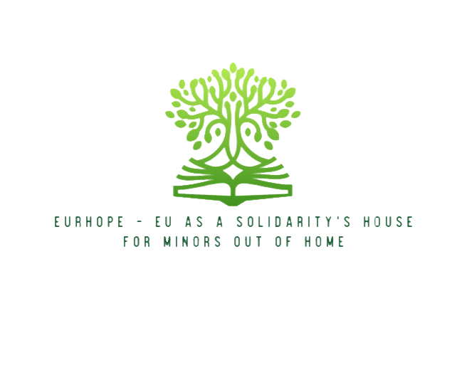




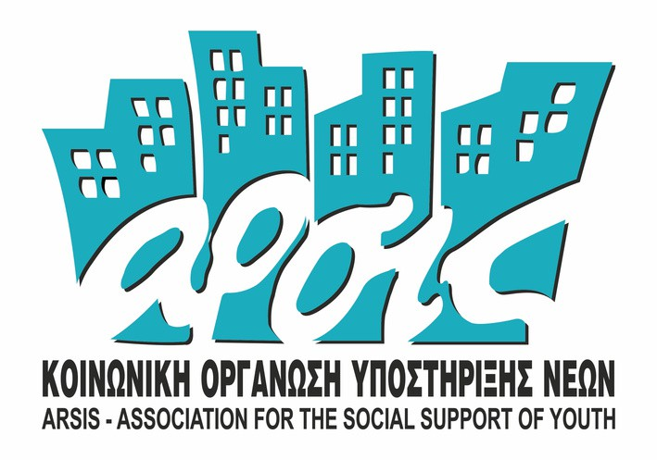


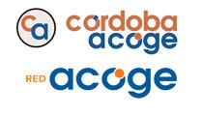
Eurhope
EU as a solidarity's house for minors out of home
2024-2026
E R A S M U S + P R O J E C T
N . 2 0 2 3 - 2 - I T 0 3 - K A 2 2 0 - Y O U - 0 0 0 1 8 4 3 7 0

Newsletter n°19
A cargo de Hellenic American Union



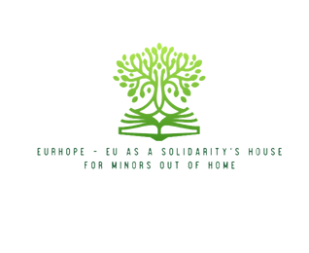
E U R H O P E


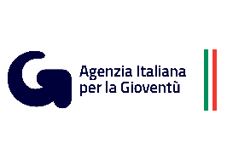
Welcome to a new edition of the EURHOPE Project Newsletter!
As the project continues to advance, we are pleased to introduce one of its most important dissemination and sustainability tools: the official website.
The platform has been designed as a central hub where professionals, stakeholders, organisations, volunteers and citizens can access comprehensive information about the project, its objectives, activities, partnership and results. It also serves as a dynamic space for sharing news, resources and achievements throughout the project lifecycle.
Through this digital environment, EURHOPE aims to ensure transparency, accessibility and long-term impact, making all project outputs available to those working to support minors living outside their family environment.
- The EURHOPE website
The official EURHOPE website provides easy access to all relevant information, contents and results about the project and its progress. Among its main sections, users can find:
• Home – An overview of the project and its contribution to strengthening civic participation and European awareness among minors out of home.
• About the Project – Detailed information about the project's objectives, target groups, expected impact and main activities.
• Partnership – A presentation of all partner organisations from Italy, Spain and Greece, highlighting their expertise and contribution to the project.
• Contact – A direct communication channel for stakeholders interested in learning more about the initiative or collaborating with the consortium.
• News – A regularly updated section featuring project milestones, meetings, events and dissemination activities, as well as interesting articles on different subjects regarding the topic of the project.

E U R H O P E

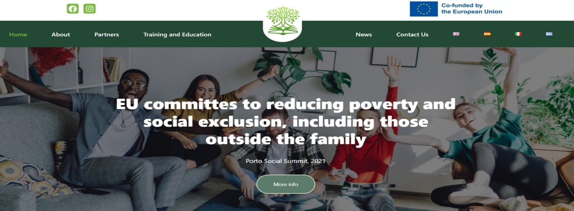

- Project results and resources
A key feature of the EURHOPE website is the dedicated area for project results and educational resources.
Visitors can access the Training Toolkit, developed to strengthen digital skills, life skills, socio-political knowledge and understanding of European values among minors and volunteer adults. In addition, the website hosts the Methodological Vademecum, designed to support professionals working with minors out of home through innovative, game-based and participatory approaches to civic engagement.
These resources have been created to ensure long-term usability and transferability, enabling organisations across Europe to benefit from the knowledge generated by the project.
The News section complements these resources by providing regular updates on project developments, upcoming activities and achievements, helping stakeholders stay connected with the EURHOPE community. We have also developed seven articles on different topics related to our project, specifically developed by our partners according to their expertise and field of work.

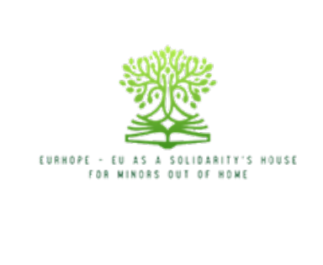
E U R H O P E

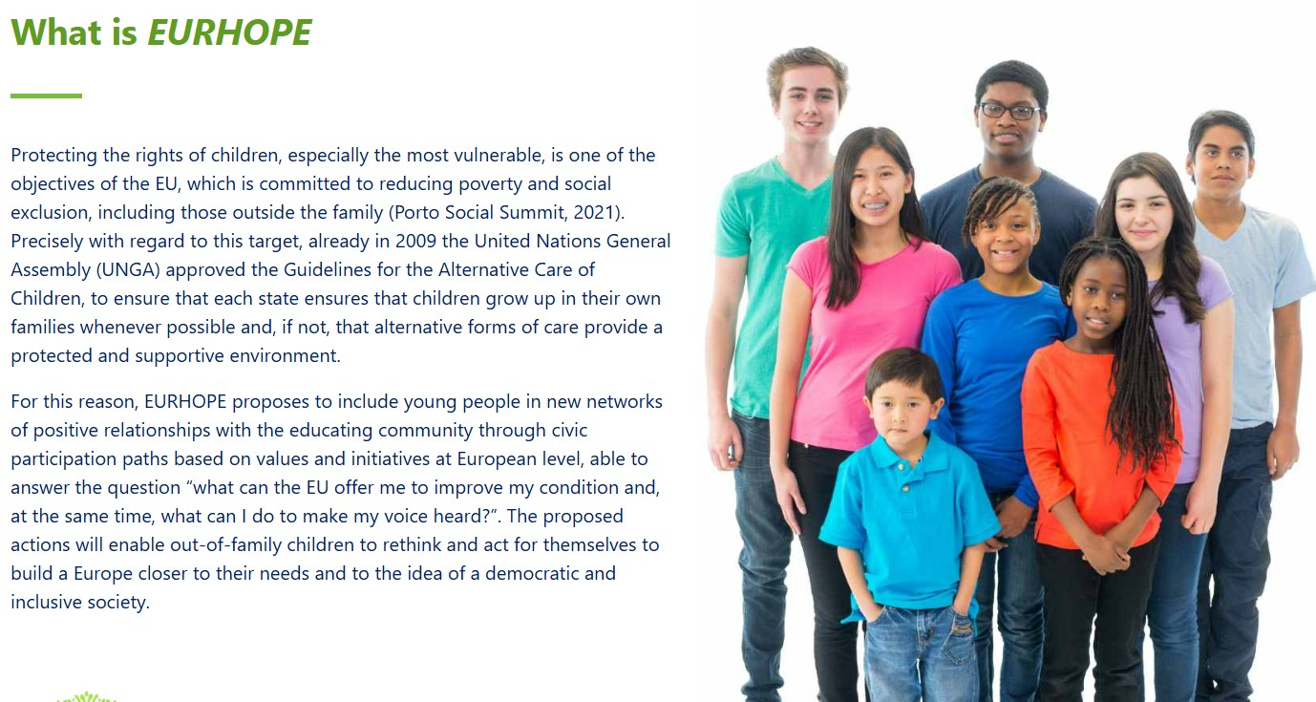

Visit the EURHOPE website and discover how the project is building opportunities for participation, inclusion and active European citizenship for minors living outside their family environment.
Official Project Website: https://eurhopeproject.eu/

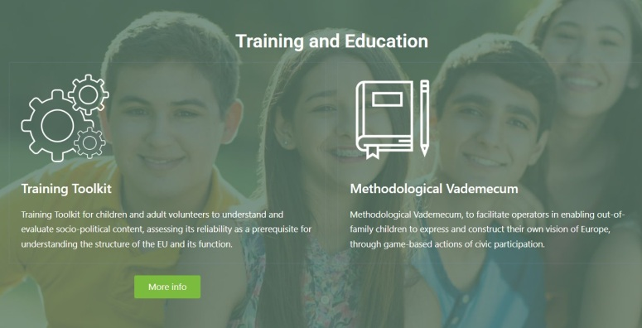
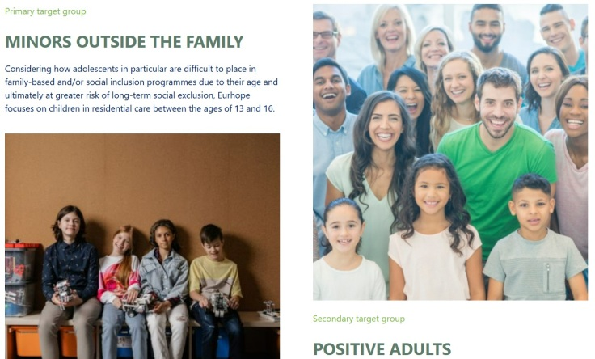

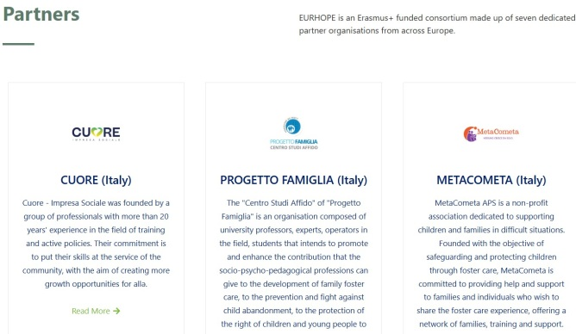
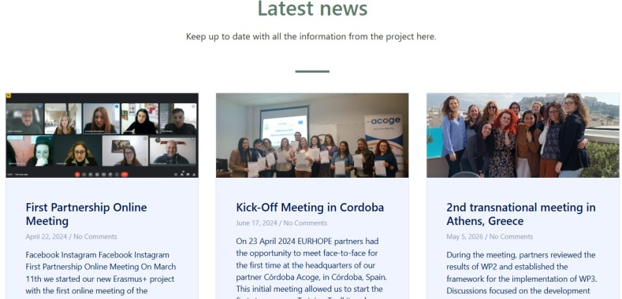

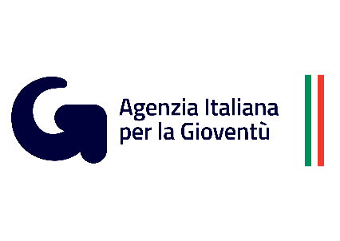

E U R H O P E

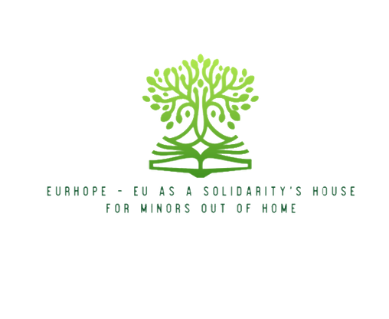



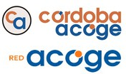

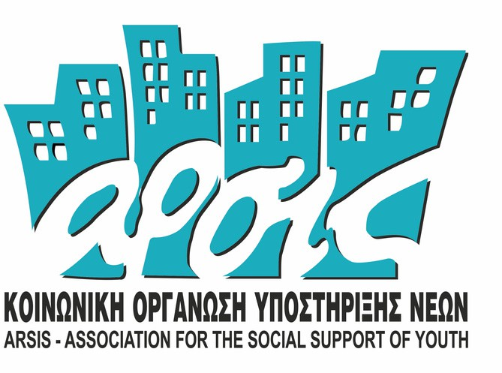



Funded by the European Union. Views and opinions expressed are, however, those of the author(s) only and do not necessarily reflect those of the European Union or the European Education and Culture Executive Agency (EACEA). Neither the European Union nor EACEA can be held responsible for them.

E R A S M U S + P R O J E C T: N . 2 0 2 3 - 2 - I T 0 3 - K A 2 2 0 - Y O U - 0 0 0 1 8 4 3 7 0

