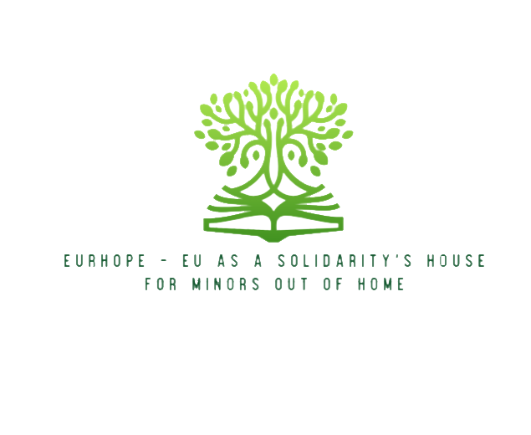




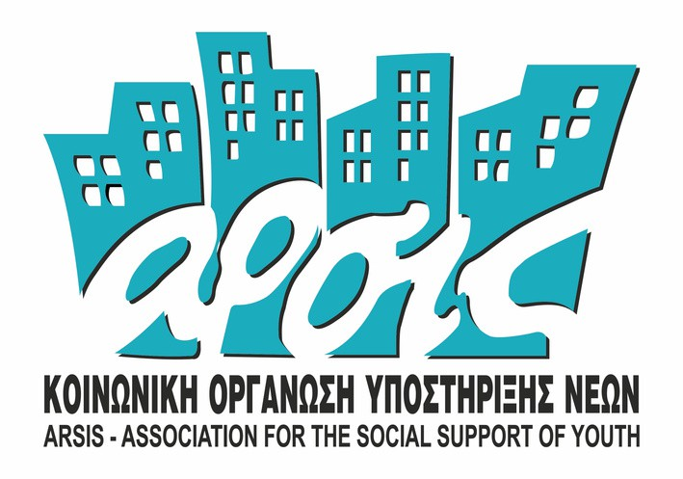


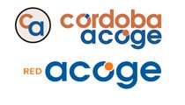
Eurhope
EU as a solidarity's house for minors out of home
2024-2026
E R A S M U S + P R O J E C T
N . 2 0 2 3 - 2 - I T 0 3 - K A 2 2 0 - Y O U - 0 0 0 1 8 4 3 7 0

Newsletter n°16
Edited by Hellenic American Union

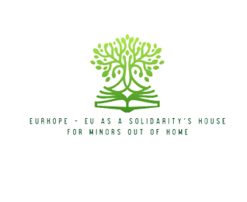
E U R H O P E

Welcome to this new edition of the EURHOPE Project Newsletter, where we share the latest developments and achievements of our Erasmus+ initiative.
EURHOPE aims to strengthen civic participation, resilience, and social inclusion for minors living outside their family environment, promoting a stronger connection with European values and democratic participation.
We have now reached the last part of the project and the artistic projects that minors prepare together with adult volunteers are the final deliverables of the EURHOPE project. Minors have been asked to select one of the key European priorities and work together to develop a creative result (i.e. presentation, movies, podcast, etc). This process is very significant for the minors understanding and participation in modern European life, for multiple reasons: a. it helps them socialize more and practice collaboration towards a goal; b. it helps build social and relational capital among minors and among minors and positive adults; c. it helps minors internalize European values.
The development of creative projects has three stages: ideation/topic selection, production, and finalization. At this point, minor participants in all countries have already selected their topic, have discussed the type of creative output they want to develop, and work at full speed to produce it. More specifically:
Minors in Italy, working in different groups, have decided to address the topic of Active Citizenship. One of the groups works on developing a Zine, an anthology of autobiographical stories, while another has created a social urban vegetable garden and they work on a film that will show all the stages of this creation-from initiation to the collection of vegetables.
Minors in Greece, have decided to address the issues of Environment and Social Justice, have already finished shooting two different films, and now work on the post-production to finalize them.
Minors in Spain, have decided to address the issues of Bullying and Cyberbullying, and now work on developing a short movie that reveals the different realities of the topic.
We are very eager to see the output of all teams! The results will also be presented during the project’s final event in Catania, Sicily in May. All products will also be uploaded to the project website.

Caro Lettore,

Dopo la prima Newsletter, presentiamo la seconda edizione con le ultime novità del nostro Progetto Eurhope!

Ora che conosci obiettivi, gruppo target, partner di Progetto e hai le necessarie informazioni sul Meeting che abbiamo avuto da poco, vogliamo evidenziare i risultati sui quali lavoreremo nei prossimi 30 mesi di Progetto:
- Risultato 1. Toolkit Formativo: Progettazione e realizzazione di interventi formativi volti a fornire le conoscenze e le competenze di base per poter partecipare alla vita sociale. Queste formazioni affronteranno 3 temi principali:
  - Digital and life skills
  - Conoscenze Socio-politiche
  - Formazione sui valori Europei
- Risultato 2. Vademecum Metodologico: Opportunità per i minori fuori famiglia di discutere di questioni di interesse globale ed europeo, di immaginare il tipo di società che vorrebbero e di intraprendere piccole azioni di partecipazione civica per fare i primi passi verso la realizzazione di questa visione.

E dove troverete tutti questi contenuti? Sul nostro sito recentemente lanciato
PIATTAFORMA UFFICIALE DI PROGETTO:
https://eurhopeproject.eu/

E R A S M U S + P R O J E C T: N . 2 0 2 3 - 2 - I T 0 3 - K A 2 2 0 - Y O U - 0 0 0 1 8 4 3 7 0

E U R H O P E

D'ora in poi, potrete già trovare tutte le informazioni necessarie per impegnarvi nel progetto EURHOPE. Su questa piattaforma troverete le seguenti sezioni:
Project news on Facebook
The project’s dissemination strategy was designed to reach the widest possible audience and ensure that all stakeholders can benefit from the project's results. Constant monitoring of the dissemination channel’s performance revealed that Facebook was the primary channel that the project news was accessed. Therefore, news on the project’s progress will be published primarily on Facebook. Follow our page: https://www.facebook.com/share/1GRXakcXDv/

We take the opportunity of this communication to wish you Happy Easter! Enjoy the holiday!
- “Home” – con un’introduzione del nostro Progetto Erasmus+
- “About” – dove troverete tutte le informazioni utili: cos'è EURHOPE, quali sono i gruppi target, gli obiettivi del progetto, ecc.
- “Partners” – tutte le organizzazioni che partecipano all'iniziativa, con il loro background, la loro contestualizzazione e i loro contatti.
- “Contattaci” – in modo che possiate inviarci tutte le vostre domande e i vostri suggerimenti.
- “News” – non perdetevi questa sezione per rimanere aggiornati su tutte le novità del progetto!
- “Formazione ed Istruzione” – qui troverete tutti i materiali di formazione che creeremo.

E R A S M U S + P R O J E C T: N . 2 0 2 3 - 2 - I T 0 3 - K A 2 2 0 - Y O U - 0 0 0 1 8 4 3 7 0


E U R H O P E

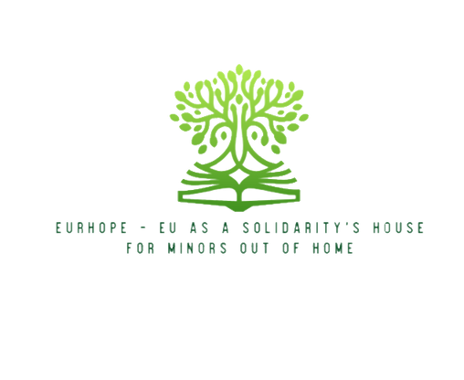



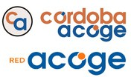

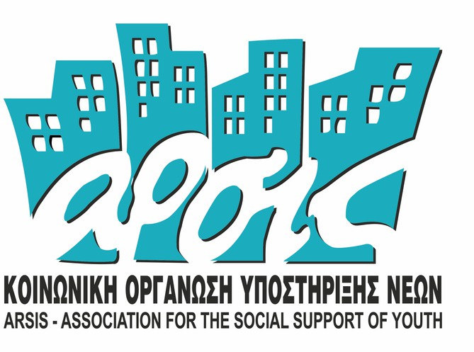



Funded by the European Union. Views and opinions expressed are, however, those of the author(s) only and do not necessarily reflect those of the European Union or the European Education and Culture Executive Agency (EACEA). Neither the European Union nor EACEA can be held responsible for them.

E R A S M U S + P R O J E C T: N . 2 0 2 3 - 2 - I T 0 3 - K A 2 2 0 - Y O U - 0 0 0 1 8 4 3 7 0

